請依據Handa’s Surprise的故事內容，將下列
水果的圖片和正確的英文名稱及描述連起來
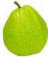
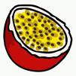
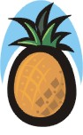

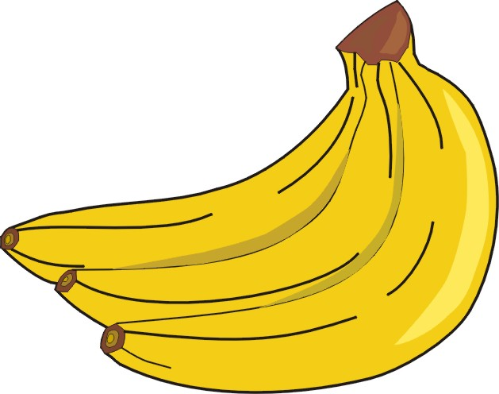
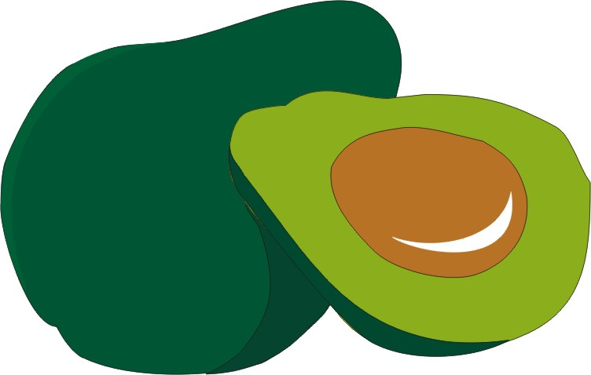
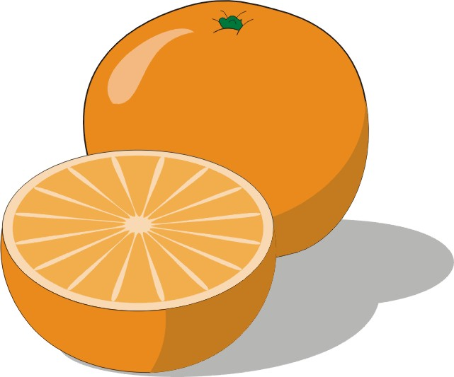
pineapple
passion-fruit
guava
mango
orange
avocado
tangy purple
sweet-smelling
spiky-leaved
soft yellow
ripe red
round juicy
creamy green
banana

